**“File Management System”**

**Using React and Firebase**

**Submitted By**

**Manthan Sharad Jadhav**

**INDEX:- PAGE NO.**

1) ABSTRACT 3

2) INTRODUCTION 4-6

3) SYSTEM FEATURES 7-10

4) TECHNICAL DETAILS 11-12

5) SYSTEM DIAGRAM 13-16

6) TESTING AND QUALITY ASSURANCE 17-18

7) SECURITY 19

8) DEPLOYMENT AND HOSTING 20

9) CONCLUSION 21

**ABSTRACT**

Imagine a tool that helps you keep your digital life in order. The File Management System is just that - a user-friendly website that makes managing your files and folders a breeze. It's built with React for the part you see, and Firebase for the behind-the-scenes magic.

The goal of this document is to be your go-to guide. It'll explain how the system works, what you can do with it, and how it's made. Whether you're a developer or a user, this document has something for you.

The project is pretty vast. You can register securely, upload files, and keep them nicely organized. Plus, you can find what you need with just a few clicks. Security is a top priority, so you don't need to worry about your data.

In simple terms, this project's all about making your digital life easier. It's a tool that keeps your files in order and helps you find them when you need to. Whether you're a tech enthusiast or just looking for a better way to manage your files, this project has got you covered.

**1. INTRODUCTION**

**1.1 Project Overview**

The File Management System is a robust and versatile web-based application meticulously designed to empower users with a comprehensive platform for the efficient organization, seamless upload, and effortless management of their digital files and folders. This system is thoughtfully constructed using React for the frontend and Firebase for the backend, guaranteeing a harmonious blend of user-friendliness and security.

In an age where digital assets are pivotal, the File Management System stands as a reliable and feature-rich solution to meet the ever-growing demands of file organization and access. It boasts a dynamic web interface that enables users to accomplish their digital file handling tasks with efficiency and ease. The system's cloud-based architecture ensures that files are not only accessible from anywhere with an internet connection but also securely stored and maintained.

**1.2 Purpose**

The primary aim of this comprehensive document is to serve as an enlightening guide, unraveling the intricacies of the File Management System. It provides an in-depth exploration of the system's architecture, a detailed exposition of its features, enlightening user stories, and the underlying technical implementations. This document serves as an invaluable resource for developers, providing insights into how the system was designed and built, while also extending its value to end-users who can find detailed guidance on system utilization.

**1.3 Scope**

The scope of the File Management System project encompasses the full spectrum of activities and functionalities integral to its seamless operation. This includes, but is not limited to:

* User registration and secure authentication processes.
* The ability to upload and organize an array of files and folders.
* An unwavering commitment to data security and the safeguarding of data integrity.

**1.4 Project Objectives**

The paramount objectives of the File Management System are carefully structured to provide users with an enriching and user-centric experience. The primary goals include:

**2. SYSTEM ARCHITECTURE**

**2.1 High-Level System Architecture**

The file management system is designed with a client-server architecture, where the client is a React-based web application, and the server is powered by Firebase services.

The high-level architecture can be divided into the following components:

**Client-Side:** This is where the React application runs. It handles user interactions, authentication, and communication with the Firebase server.

**Server-Side:** Firebase serves as the backend for the system. It provides features like real-time database, authentication, and cloud storage for file storage.

**Database:** Firebase Realtime Database is used to store folder and file metadata. This database allows us to sync data across clients in real-time, providing a collaborative experience.

**File Storage:** Firebase Cloud Storage is used to store the actual file contents. It ensures secure, scalable, and efficient storage of files.

**2.2 Technology Used**

The file management system employs various technologies to deliver its functionality:

**React:** The user interface is built using React, a popular JavaScript library for building interactive UIs.

**Firebase:** Firebase provides a backend-as-a-service (BaaS) platform, including Realtime Database for metadata and Cloud Storage for file storage. Firebase Authentication is used for user management.

**Redux:** Redux is used for state management in the React application. It centralizes the application's state for easy access and management.

**React Router:** React Router is used for client-side routing to navigate between different views in the application.

**React-Redux:** This library is used to connect the React application with the Redux store, allowing for state management.

**2.3 Database Design**

The database design of the file management system is organized to store both folder and file metadata efficiently. It's based on a NoSQL structure, which is well-suited for the hierarchical nature of file and folder relationships.

**Folders:** Each folder is represented as a separate record in the database. It contains attributes like folder name, parent folder ID, user ID, and an array to maintain the folder hierarchy.

**Files:** File records store metadata like file name, parent folder ID, user ID, file type, file size, and a URL to the actual file content in Firebase Cloud Storage.

**3. SYSTEM FEATURES**

**3.1 User Management**

**3.1.1 User Registration**

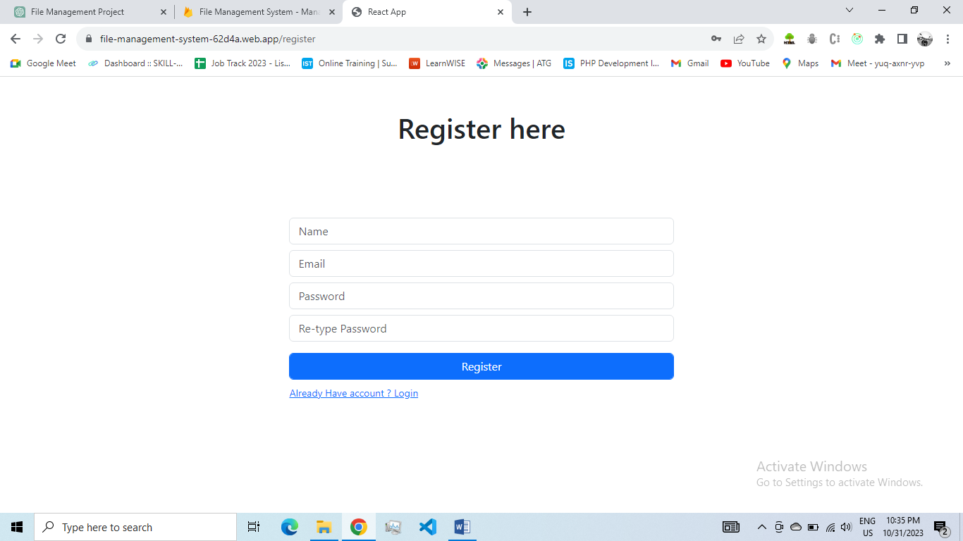

**Description:** Users can register for an account using a valid email address and password.

**Implementation:** The registration form collects user details, validates input, and creates a user account in Firebase Authentication.

**3.1.2 User Authentication**

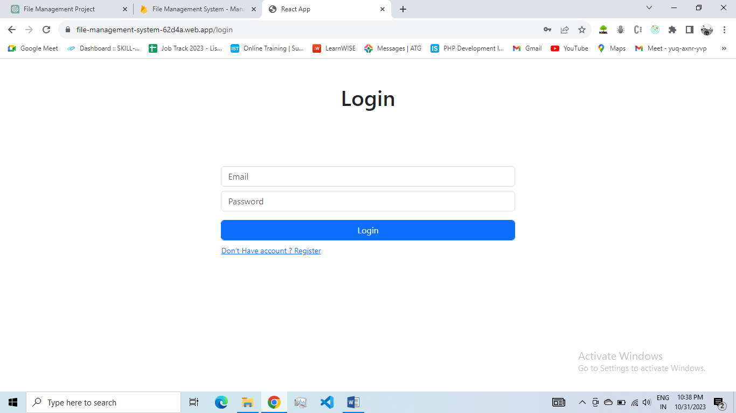

**Description:** Registered users can log in to the system securely.

**Implementation:** Firebase Authentication handles user logins, providing secure access to the system.

**3.2 Folder Management**

**3.2.1 Create Folders**

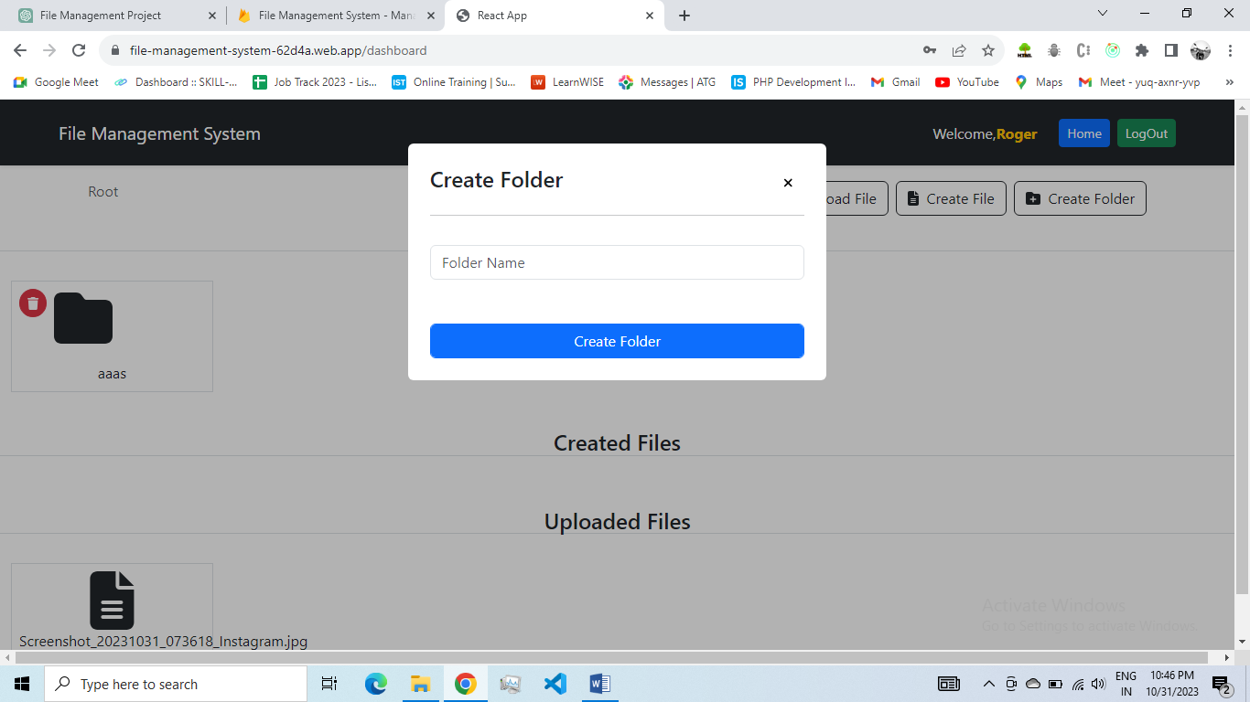

**Description:** Users can create new folders to organize their files.

**Implementation:** The application provides a UI for creating folders, and the folder structure is managed in Firebase Firestore.

**3.2.3 Delete Folders**

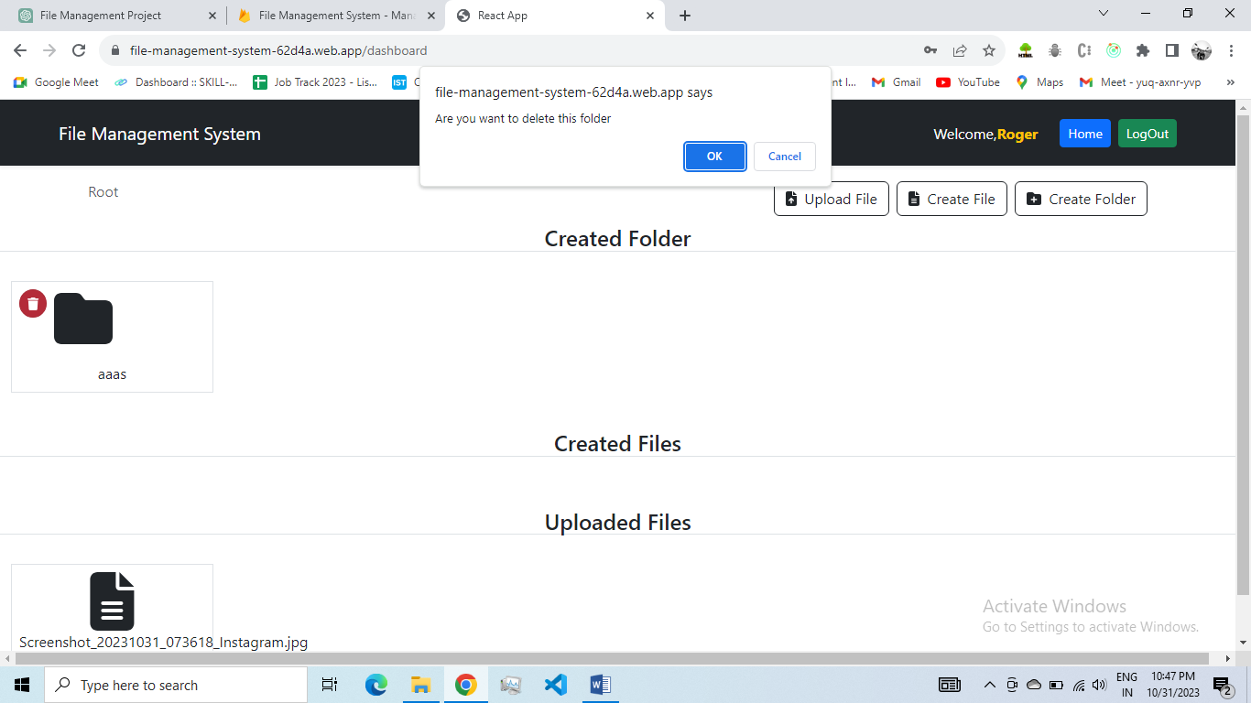

**Description:** Users can delete folders, including their contents.

**Implementation:** A delete action triggers the removal of the folder and its associated files from the database.

**3.2.4 Folder Hierarchy**

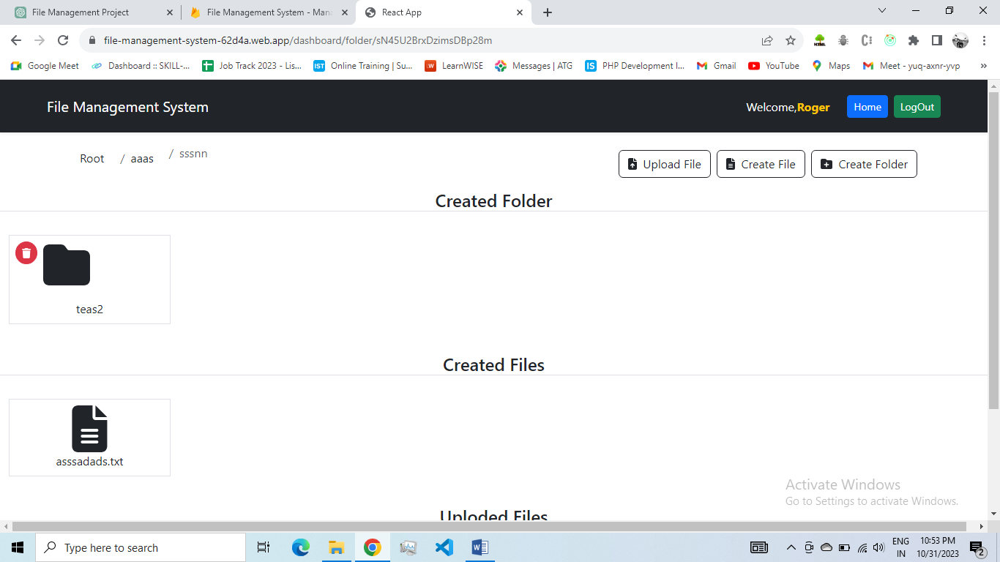

**Description:** Support for a hierarchical folder structure.

**Implementation:** Folders can be organized hierarchically, allowing users to create subfolders within folders.

**3.3 File Management**

**3.3.1 Upload Files**

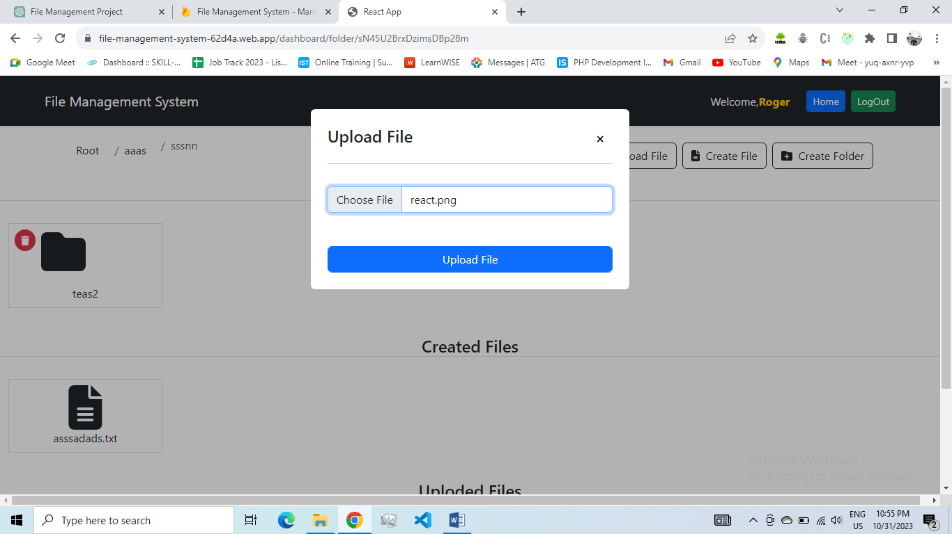

**Description:** Users can upload files to their folders.

**Implementation:** The application allows users to select and upload files, which are stored in Firebase Storage, and associated metadata in Firestore.

**3.3.2 Create Files and Save file**

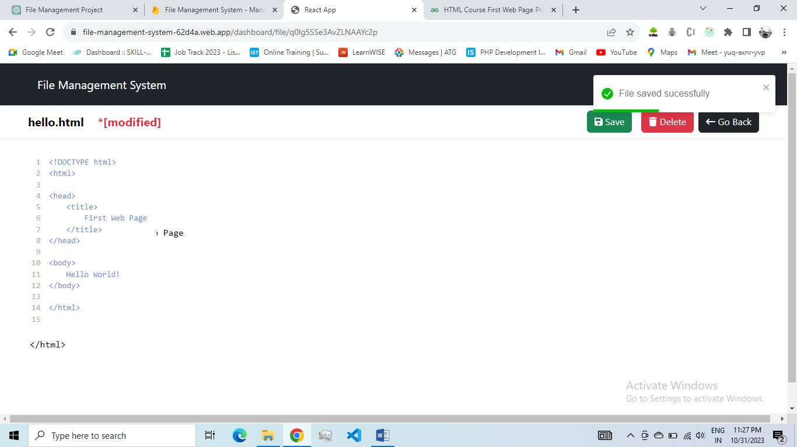

**Description:** Users can create files and save file with content to fire-store .

**Implementation:** The application allows users to create files, and write the file and after that save file data to firebase

**3.3.3 Download Files and Delete Files**

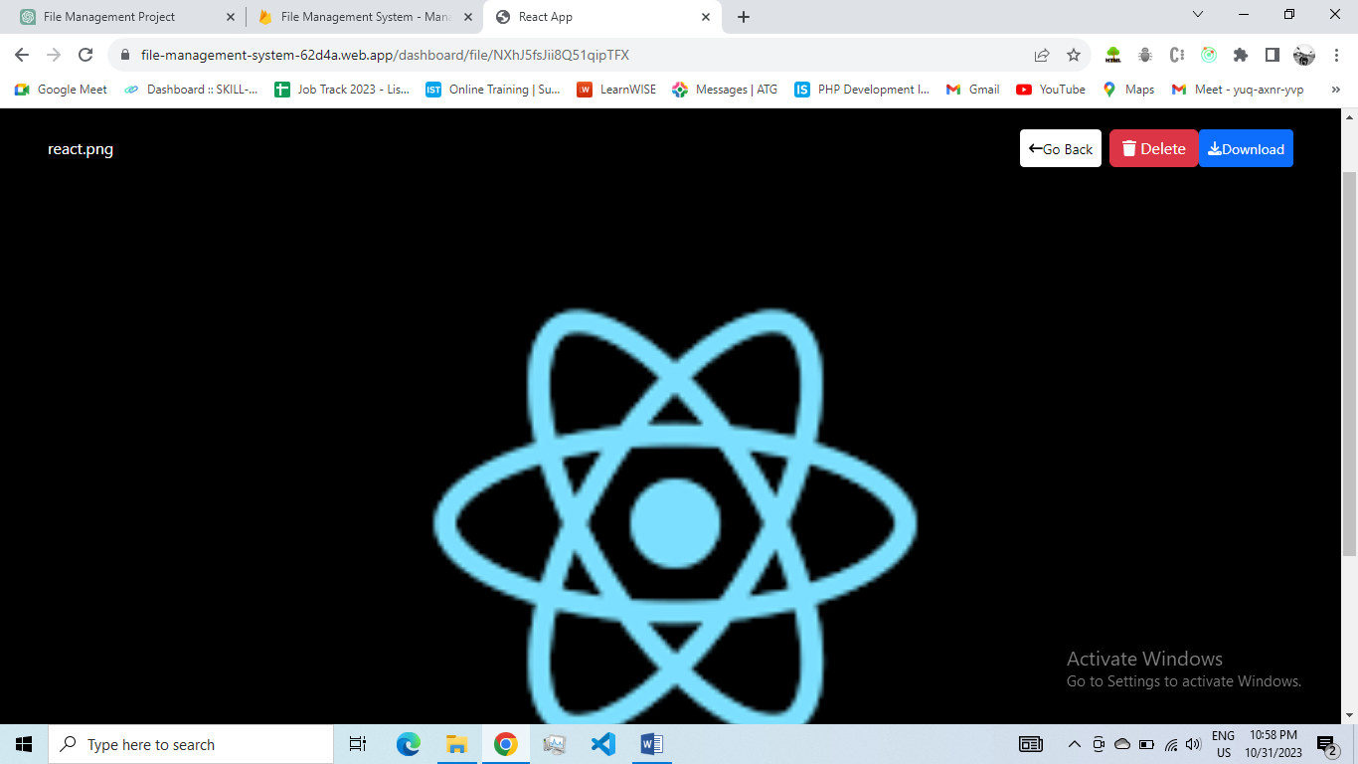

**Description:** Users can download files and delete files stored in their folders.

**Implementation:** Download links are provided for files, and files are fetched from Firebase Storage.A delete action removes the file from Firebase Storage and updates the database accordingly

**4. TECHNICAL DETAILS**

**4.1 Frontend Implementation**

The frontend of the File Management System is built using React, a popular JavaScript library for building user interfaces. React allows for the creation of a dynamic and responsive user interface. Key components include:

**Components:** Various components are developed for user interfaces, including the login/registration screens, file explorer, folder navigation, and more.

**State Management:** React's state management is utilized for tracking user interactions, making the interface responsive and interactive.

**Routing:** React Router is employed to handle navigation and ensure different components are rendered based on the current URL.

**4.2 Backend Implementation**

The backend of the system is responsible for managing user accounts, file storage, and business logic. It's implemented using Firebase, a robust cloud-based platform. Key components include:

**Authentication:** Firebase Authentication is used for secure user registration and login. It provides methods for user identity verification.

**Database:** Firebase Firestore, a NoSQL database, is employed to store user data, file metadata, and folder structures.

**File Storage:** Firebase Cloud Storage is utilized for secure and scalable file uploads and storage. It enables efficient handling of various file types.

**Serverless Functions:** Firebase Functions allow for custom serverless functions that handle complex logic, like file deletion and sharing.

**4.3 Firebase Integration**

Firebase serves as the backbone of the File Management System. It offers services like Authentication, Firestore, and Cloud Storage to manage user accounts, data, and files. These Firebase services are integrated into both the frontend and backend components.

**4.4 Database Structure**

The database structure in Firebase Firestore is organized to store user-specific data, including folders, files, and user account information. It follows a hierarchical structure where each user has their unique document containing subcollections of folders and files.

**4.5 APIs and Services**

Firebase provides REST APIs for Authentication, Firestore, and Cloud Storage. The frontend communicates with these APIs to perform actions like user registration, file uploads, and data retrieval. These services are integrated securely using API keys and authentication tokens.

**4.6 File Upload and Storage**

File upload and storage are managed through Firebase Cloud Storage. Files are uploaded by users, and Firebase ensures their secure storage. The system generates unique URLs for each file, allowing for efficient retrieval and sharing.

**5. SYSTEM DIAGRAM**

**5.1 System Design**

Register

Home

Login

Upload

File

Dashboard

**User**

Create Folder

Create File

**Fig. System Design**

With the help of this module, user can perform the following Tasks/Actions. User can login or signup for this application, then user can go to dashboard then it can create folder,create file or upload file. User can see the all data at dashboard home page. User can also delete the file as well as folder

**5.2 Data flow Diagram**

**User**

**Signup**

**Login**

**Log out**

**Dashboard**

**Create Folder**

**Upload File**

**Create File**

**Download File**

**Save file Data**

**Create subfolder**

**Delete file**

**Delete file**

The data flow in the File Management System is as follows:

**User Registration and Authentication:** Users register with their email and password. Firebase Authentication ensures secure and authorized access.

**User Dashboard:** After authentication, users are directed to the dashboard. The dashboard retrieves user-specific folder and file data from Firestore.

**File and Folder Management:** Users can create, delete, and organize files and folders. Changes are reflected in the database.

**File Upload and Storage:** When users upload files, Firebase Cloud Storage securely stores them and provides unique download URLs.

**File Previews:** When a user clicks on a file, the system displays a preview based on the file type.

**Breadcrumb Navigation:** Users can navigate through folders by clicking on breadcrumb links. Each click triggers a data retrieval event from Firestore.

**5.3 Use Case Diagram**



Firebase Database

A Use Case Diagram is a visual representation of the functional requirements of a system and how users interact with it. In the context of the File Management System, the Use Case Diagram outlines the various actions that users can perform and their interactions with the system. Below is a description of the key elements of the Use Case Diagram:

**Actors**

**User:** Represents the primary actor who interacts with the File Management System. Users can perform various actions within the system.

**Use Cases**

**Register:** This use case allows users to create a new account within the system. Users provide registration details, including username, email, and password.

**Login:** Users can log in to their existing accounts by providing their credentials, including email and password. Successful login grants access to the system.

**View Dashboard:** After logging in, users can view their personalized dashboard. The dashboard serves as the central hub for file and folder management.

**Create Folder:** Users have the ability to create folders to organize their files effectively. They specify a folder name, and the system creates the folder.

**Create File:** Users can create new files within folders. They provide a file name and select a destination folder for the new file.

**Upload File:** This use case allows users to upload files to the system. Users select a file from their local device and specify the destination folder.

**Delete File:** Users can delete files they no longer need. The system prompts users to confirm file deletion to prevent accidental data loss.

**Delete Folder:** Users have the option to delete folders. The system checks if the folder is empty before allowing deletion.

**6. TESTING AND QUALITY ASSURANCE**

**6.1 Testing Objectives**

The primary objective of testing in the File Management System is to ensure that all features and functionalities work as expected, and the system operates with efficiency and reliability. Key testing objectives include:

**Functionality Testing:** Verify that all features, including user registration, folder creation, file upload, and search, are functioning correctly.

**Usability Testing:** Evaluate the user interface for ease of use, navigation, and overall user experience.

**Security Testing:** Identify and address potential vulnerabilities, ensuring that user data is protected.

**Performance Testing:** Assess the system's response time and resource consumption under various load conditions.

**Compatibility Testing:** Confirm that the system works seamlessly on different web browsers and devices.

**Regression Testing:** Ensure that new updates or features do not break existing functionalities.

**6.2 Test Cases**

A comprehensive suite of test cases is developed to cover various aspects of the File Management System. Test cases include:

* **User registration and login.**
* **Folder creation and management.**
* **File upload and management.**
* **User interface navigation and usability.**
* **Performance under different load scenarios.**
* **Compatibility across browsers and devices.**
* **Security assessments for data protection.**

**6.3 Testing Tools**

Various testing tools and frameworks are used to facilitate testing:

**Jest and React Testing Library:** For unit and integration testing of React components.

**Cypress:** For end-to-end testing and user interaction simulations.

**Firebase Security Rules Simulator:** For security testing to ensure that authentication and authorization rules are correctly enforced.

**6.4Bug Tracking**

A bug tracking system is implemented to manage and resolve issues. It allows the development team to:

* **Log and categorize bugs and issues.**
* **Assign issues to specific team members.**
* **Set priorities and deadlines.**
* **Track the status and progress of issue resolution.**

**7. SECURITY**

**7.1 Authentication and Authorization**

Authentication is handled through Firebase Authentication, which provides secure user registration and login. User credentials are protected during transmission, and Firebase ensures the verification of user identities. Authorization is enforced by Firebase Security Rules, which define who can access certain parts of the system.

**7.2 Data Encryption**

User data, including files and personal information, is protected through data encryption in transit and at rest. Firebase Cloud Storage and Firestore use SSL/TLS encryption protocols to secure data transmission. Additionally, Firebase manages encryption keys to safeguard data storage.

**7.3 Best Practices**

Security best practices are followed throughout the development process, including:

* **Regular security audits and vulnerability assessments.**
* **Periodic review and update of Firebase Security Rules.**
* **Secure password policies and multi-factor authentication for users.**

**8. DEPLOYMENT AND HOSTING**

**8.1 Deployment Steps**

The deployment process involves several steps:

**Build the Application:** The React application is built and optimized for production.

**Configure Firebase:** Firebase hosting is configured with necessary settings and hosting targets.

**Deploy to Firebase:** The application is deployed to Firebase using Firebase CLI.

**8.2 Hosting on Firebase**

Firebase is chosen as the hosting platform due to its scalability, security, and ease of use. It offers a reliable hosting solution with automatic scaling, HTTPS support, and content delivery through a global CDN. Firebase Hosting provides the following benefits:

* SSL/TLS encryption for secure data transmission.
* Content delivery via a worldwide network of CDNs for fast loading.
* Simple and straightforward deployment process.
* Continuous integration and continuous deployment (CI/CD) capabilities for efficient updates.
* Scalability to handle varying traffic loads.

**CONCLUSION**

The File Management System is a versatile and user-centric web application built on the foundation of React for the frontend and Firebase for the backend. Throughout this project documentation, we have explored the system's design, architecture, features, and technical details, providing an in-depth understanding of its capabilities and functionality.

The primary goal of this system is to offer users an efficient and secure platform for managing their files and folders. It empowers users with the ability to organize, upload and manage their digital assets with ease.

Key features of the File Management System include user management, folder management, file management, security and authentication. Users can create and organize folders, upload and manage files, and confidently secure their data, knowing that the system prioritizes their privacy and security.

The technical implementation of this system combines the frontend and backend components seamlessly. React ensures a responsive and user-friendly interface, while Firebase handles the backend operations, including user authentication, file storage, and database management.

The system's user interface is designed with simplicity and efficiency in mind. Users can intuitively navigate the dashboard, creating folders, files, and uploading data effortlessly.

From a security perspective, the system leverages Firebase's robust authentication and storage capabilities, safeguarding user data and ensuring its integrity. Users can trust the system with their important files and confidential information.

In conclusion, the File Management System is a valuable asset for individuals and organizations looking to streamline their digital file management processes. Its user-friendly design, powerful features, and robust security measures make it a dependable choice for effective file organization and management. Whether you are a professional seeking efficient document control or an individual looking to manage personal files, this system is designed to meet your needs with excellence.